A. Python Environment with Conda

A.1. Install Anaconda3 on Ubuntu 22.04
Step 1: Download the anaconda3 installer from https://mirrors.tuna.tsinghua.edu.cn/anaconda/archive/,
$ cd $HOME
$ wget https://mirrors.tuna.tsinghua.edu.cn/anaconda/archive/Anaconda3-2025.12-2-Linux-x86_64.sh
Step 2: Run anaconda3 installer,
$ cd $HOME
$ chmod 777 Anaconda3-2025.12-2-Linux-x86_64.sh
$ ./Anaconda3-2025.12-2-Linux-x86_64.sh
ENTER
yes
ENTER
yes

Step 3: Clean the installer,
$ cd $HOME
$ rm -rf Anaconda3-2025.12-2-Linux-x86_64.sh

A.2. Anaconda3 Usage on Ubuntu 22.04
Step 1: List conda environments,
$ conda info --envs

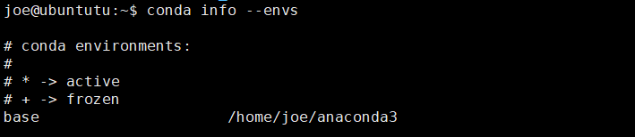
Step 2: The default conda environment is the base above, to start the default conda environment, we can use the following command,
$ conda activate
To stop the default conda environment, we can use the following commands,
$ conda deactivate
Step 3: To create a customized conda environment with python 3.10.12 and numpy 1.26.4, we can use the following command,
$ conda create --name env_py_3_10_12 python=3.10.12 numpy=1.26.4
Then run the conda environment,
$ conda activate env_py_3_10_12
$ python –version

To stop the conda environment,
$ conda deactivate

A.3. Uninstall Anaconda3 on Ubuntu 22.04

Step 1: Check the installation directory,
$ conda info --envs
# conda environments:
#
# * -> active
# + -> frozen
base /home/joe/anaconda3
env_py_3_10_12 * /home/joe/anaconda3/envs/env_py_3_10_12

Step 2: Remove conda from the shell,
$ vi ~/.bashrc // delete conda configurations
$ source ~/.bashrc // save it

Step 3: Remove anaconda files,
$ cd $HOME
$ rm -rf anaconda3

Step 4: Verify the uninstallation,
$ conda --version
-bash: /home/joe/anaconda3/bin/conda: No such file or directory

B. Golang Environment

B.1. Install Golang on Ubuntu 22.04
Step 1: Download the Golang installer from https://go.dev/dl/,
// Go v1.18.10
$ cd $HOME/downloads
$ wget https://go.dev/dl/go1.18.10.linux-amd64.tar.gz
$ scp go1.14.8.linux-amd64.tar.gz root@172.31.210.70:$HOME/downloads // scp within the great wall
$ tar -xzf go1.18.10.linux-amd64.tar.gz
$ sudo rm -rf /usr/local/go
$ sudo mv go /usr/local
$ mkdir -p $HOME/go
$ echo 'export PATH=$PATH:/usr/local/go/bin' >> ~/.bashrc
$ echo 'export GOPATH=$HOME/go' >> ~/.bashrc
$ source ~/.bashrc
$ go version

B.2. Run Golang Examples on Ubuntu 22.04
Step 1: Example 1 - Hello World,
$ cd $HOME
$ mkdir go_code
$ cd go_code
$ go mod init your_module_name/hello // replace with your_module_name

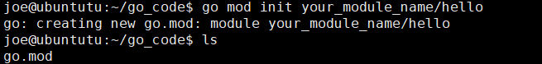

$ vi hello.go // create the corresponding hello.go file

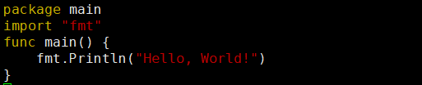

$ go build hello.go
$ ./hello

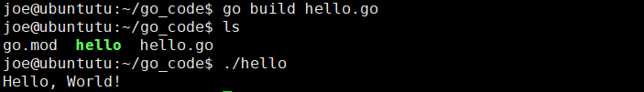

Step 2: Example 2 – Use Official External Package,
$ cd $HOME/go_code
$ vi random.go

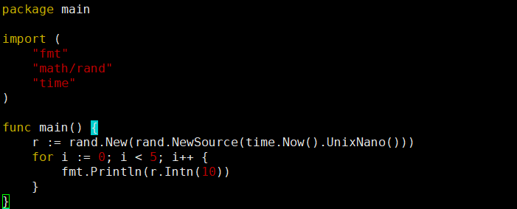

$ go build random.go
$ ./random
Step 3: Example 3 – Use Third-Party External Package,
$ // use third-party external package, e.g., github.com/sammy/random
$ cd $HOME/go_code
$ go mod init github.com/sammy/random
$ ls
go.mod
$ cat go.mod

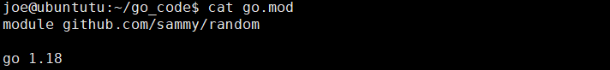

$ // add a thrid-party external package
$ go env -w GOPROXY=https://goproxy.cn // if within the great wall
$ go get github.com/google/uuid@latest

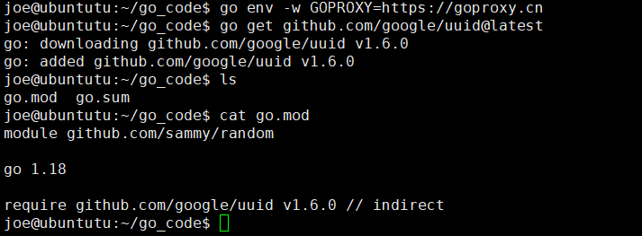

$ cat go.sum

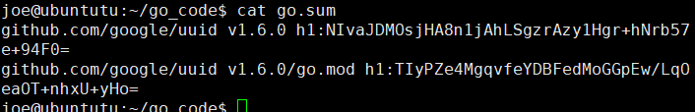

$ ls // We have now prepared well the dependencies,

Next, we parpare the main file, the required depended files is “github.com/google/uuid” required as follows,
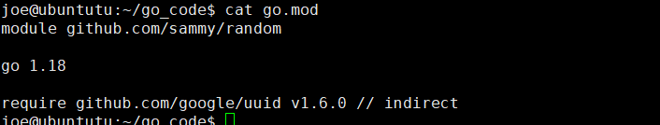

$ touch main.go

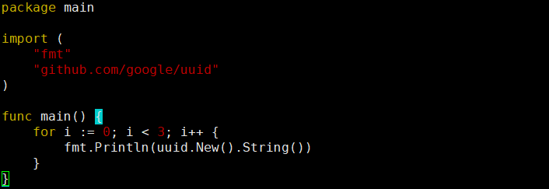

$ go build main.go
$ ./main

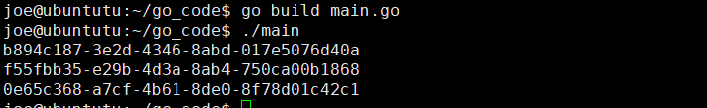

$ go mod tidy // run this after adding or removing imports

Step 4: Example 4 – Import Local Same Packages within a Module,
$ cd $HOME
$ cd go_code
$ vi utils.go

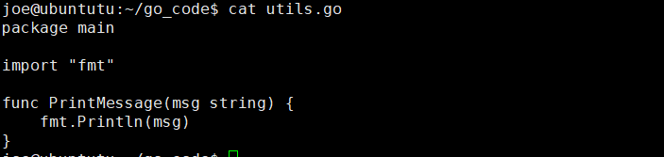

$ vi main.go

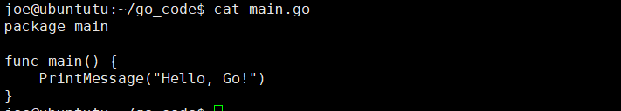

$ go build main.go utils.go

Step 5: Example 5 – Import Local Different Packages within a Module,
$ cd $HOME
$ cd go_code
$ go mod init your_module_name // the module name is “your_module_name”

$ vi main.go

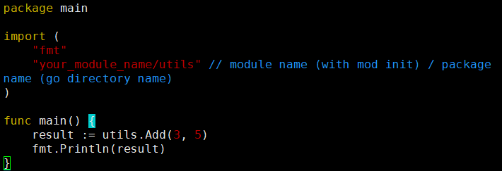

$ mkdir utils
$ cd utils
$ vi math.go

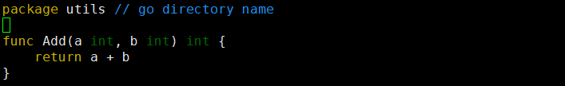

$ cd $HOME/go_code
$ go build main.go
./main

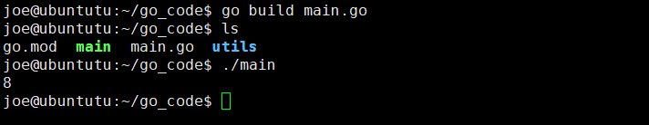

B.3. Manage Golang Modules
Step 1: Prepare your project,
$ cd $HOME
$ mkdir BN_Commitment
$ cd BN_Commitment
$ vi main.go

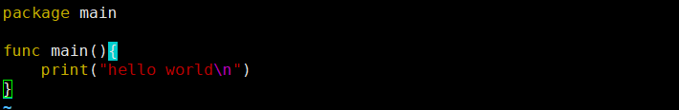

$ go run main.go

Step 2: Our project imports external modules,
$ vi main.go

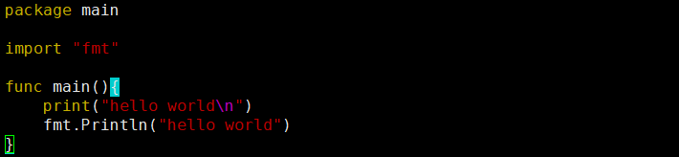

$ go run main.go

Step 3: Our project imports third-party external modules,
$ vi main.go

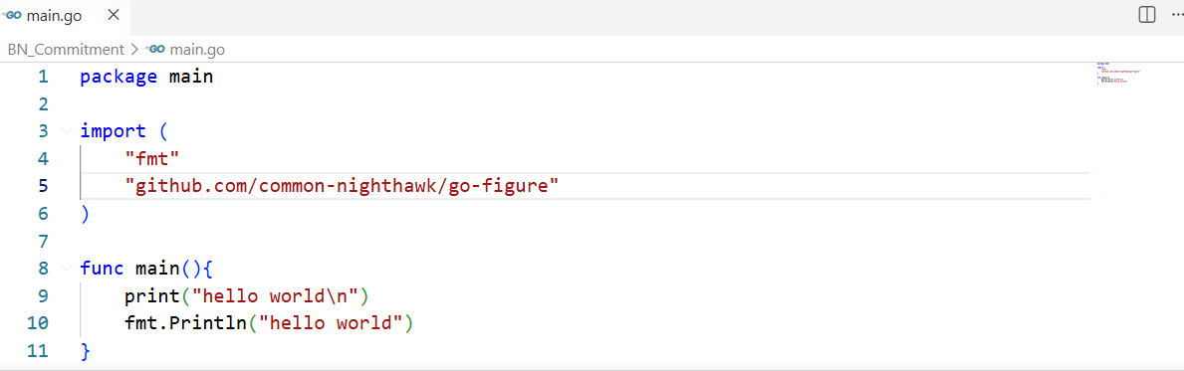

This raises errors,

// First, we create a mod for our project,
$ go mod init github.com/Canhui/BN_Commitment

// Second, we get the third party library
$ go get github.com/common-nighthawk/go-figure
$ go mod tidy

// Third, we can run the codes
$ go run main.go

// Fourth, if we remove third party codes, then we use go mod tidy to manage modules,
$ go mod tidy // this will clean the go.mod automatically
$ go run main.go

Merkle Tree

1.1. Prepare the Hosts

Step 1 (Prepare): All machines prepare the host names,
$ vi /etc/hosts

172.31.210.67 cli
172.31.210.70 peer0.org1.example.com
172.31.210.71 peer0.org2.example.com
172.31.210.72 orderer.example.com

Step 2 (Prepare): CLI p
chines including peers and orderers
Hello world smart contract with python https://www.youtube.com/watch?v=mL7-oU_44wc

https://github.com/algorandfoundation/algokit-templates/tree/main/examples/python-smart-contract
https://forum.algorand.co/t/help-with-algokit/14252/2
https://www.risein.com/courses/build-on-algorand/what-is-algorand

Invoke python 2 codes via python 3 https://community.esri.com/t5/python-questions/execute-python-2-code-via-python-3/td-p/431703
https://stackoverflow.com/questions/27863832/calling-python-2-script-from-python-3

KZG commitment in python 3: https://github.com/CleanPegasus/kzg-commitment-python

To Do 1: https://github.com/wealdtech/go-merkletree
To Do 2: https://github.com/mahmudsudo/kzg_go
import hashlib
import binascii

# 定义三笔交易的哈希值（示例数据，格式为小端字节序）
tx1_hex = "c06fbab289f723c6261d3030ddb6be121f7d2508d77862bb1e484f5cd7f92b25"
tx2_hex = "5a4ebf66822b0b2d56bd9dc64ece0bc38ee7844a23ff1d7320a88c5fdb2ad3e2"
tx3_hex = "b9d1f25e4c78fcfc9e8b5f9c6f7e8d4a3b2c1d0e9f8a7b6c5d4e3f2a1b0c9d8e" # 第三笔交易示例

# 将十六进制字符串反转（转为小端序）并解码为字节
tx1 = binascii.unhexlify(tx1_hex)[::-1]
tx2 = binascii.unhexlify(tx2_hex)[::-1]
tx3 = binascii.unhexlify(tx3_hex)[::-1]

# 第一轮：两两配对。由于是3笔交易，将最后一笔（tx3）复制一份与自身配对
# 配对组合为：(tx1, tx2) 和 (tx3, tx3)
pair1_hash = hashlib.sha256(hashlib.sha256(tx1 + tx2).digest()).digest()
pair2_hash = hashlib.sha256(hashlib.sha256(tx3 + tx3).digest()).digest()

# 第二轮：对第一轮产生的两个哈希值再次配对，生成最终的 Merkle root
# 注意：这里只有两个节点，直接配对
merkle_root_bytes = hashlib.sha256(hashlib.sha256(pair1_hash + pair2_hash).digest()).digest()

# 将结果转换为大端序的十六进制字符串（与比特币区块头中的格式一致）
merkle_root_hex = binascii.hexlify(merkle_root_bytes[::-1]).decode('utf-8')

print("Merkle Root (大端序):", merkle_root_hex)

Ref 1：https://stackoverflow.com/questions/68971973/calculate-merkle-root-from-2-transaction

Ref 2：https://btcscan.org/block/000000000043a8c0fd1d6f726790caa2a406010d19efd2780db27bdbbd93baf6?expand

Ref 3： https://btcscan.org/block/00000000000036312a44ab7711afa46f475913fbd9727cf508ed4af3bc933d16

